User Manual

ASK ME

2022

**Introduction:**

This document covers the procedure to setup the basic requirements for a project. The project is developed in **MERN** stack with the base of JavaScript and we have to setup the environment to run and test the project. **MERN** covers the following technologies here **‘M**’ is MongoDB, **‘E’** is Express JS, **‘R’** is React JS and **‘N’** is Node JS.

We have to install Git bash, which will be used for version control, and it keep tracks the changes inside the code. Node JS will be used which is JavaScript runtime environment and we will see how to install the Node JS for setting up the project and for building our backend. We have to install VS Code, setup MongoDB for storing data in the database and we will cover everything in this document.

Now we will start installing everything, which is required to run the Project.

**VS Code:**

VS Code is the text editor, which we have to download and install in order to run the project, it is a platform, which is a text editor and is used to write the code. We can then run the code with the help of node package manager, which we will be covering, in the next section. VS code is used to write code, test, debug and to make changes before deploying it public use.

Go the Vs Code Website <https://code.visualstudio.com/> and click on download. Below is the attached screenshot for downloading Vs Code from the website.

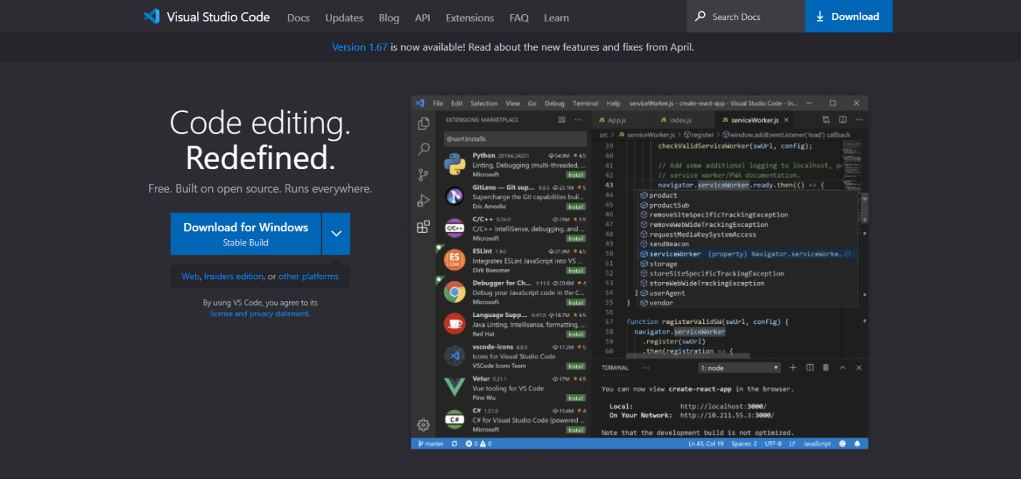

After downloading the Vs Code, we have to install VS on our machine. When the installation complete then we can open the text editor to use and run the code.

**Node JS:**

Node.js is an open-source, cross-platform, back-end JavaScript runtime environment that runs on the V8 engine and executes JavaScript code outside a web browser. It is the very first thing, which we need to install in order to setup the project for React and Node.

We need to go to the Node JS website <https://nodejs.org/en/> and download the .exe file to install into the machine. Below is the attached screenshot of Node website and we have to click on the Download button for recommended Users.

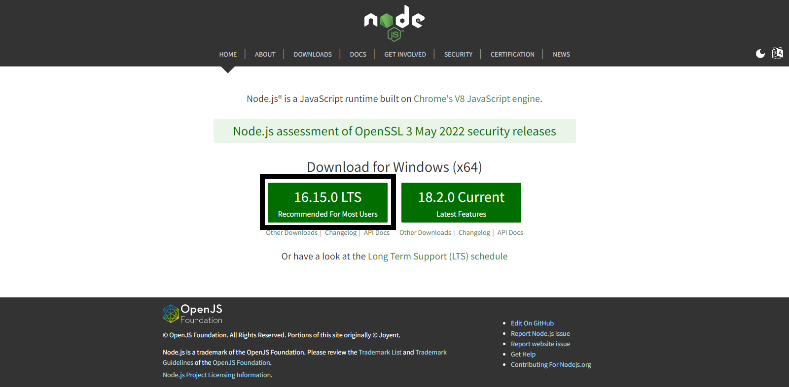

After downloading the Node, we have to install Node JS. After downloading Node, we can check whether the latest version is installed or not. We have to open the command prompt and run the following command “npm --version” or “npm -v” in Mac as well. Below is the attached screenshot in PC of how to check the npm version, npx version and node version. All are comes under one package and confirm the Node installation.

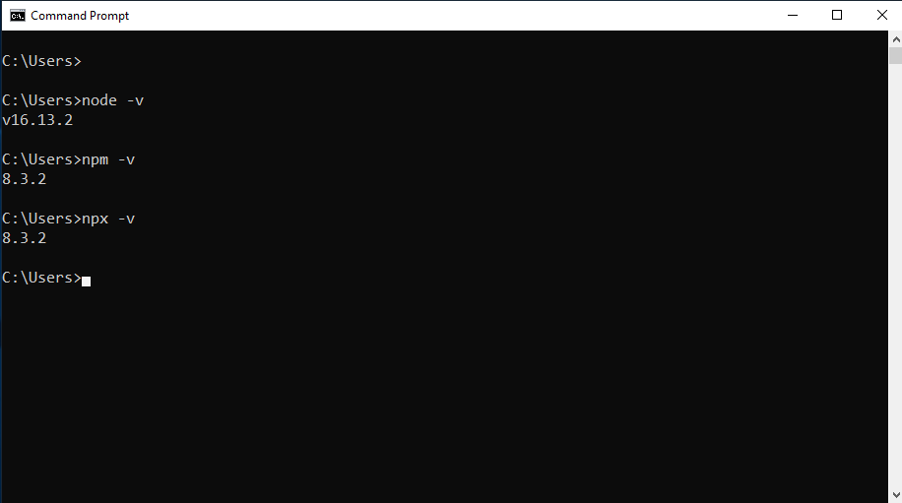

This indicates that the Node is installed locally.

**Git Bash:**

Git Bash, quite simply, is an application for Microsoft Windows that emulates the "original" Git version control system as it was built for Unix-style environments. Git bash is used to manage code which helps to push code to the Git repo so it can be saved in cloud. It helps us to clone the repository directly from the GitHub.

We have to go to the following website: <https://git-scm.com/downloads>

Below is attached screenshot to download the Git Bash

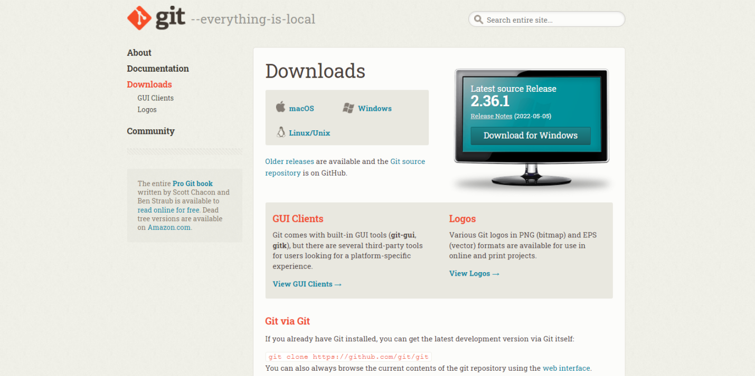

When download completes, then we have to install the Git bash on machine. The procedure is simple and it will not take much time to complete the installation process.

**MongoDB:**

After the Node Setup, We have to create connection String from the MongoDB Atlas website from the following link: <https://account.mongodb.com/account/login>

We have to make a new account and then we need to create a new connection string which is cloud based and we can store data in MongoDB by setting up the connection string.

The basic requirements to setup the MERN stack application is completed. Now we will see how we can run the application by combining these technologies and utilize them.

**Implementation:**

Now we have to run the project by installing the required packages and provide the API keys for certain packages.

**Git Bash:**

First, we have to clone the code repo from the given link: <https://github.com/ZARYABZEE/ask-me.git> with the help of Git bash. We have to open the Git bash by pressing the right click in any folder we want to clone the code. In the Menu we have to select Git bash here, a terminal window will be open and we have to type the following command: **git clone <https://github.com/ZARYABZEE/ask-me.git>**

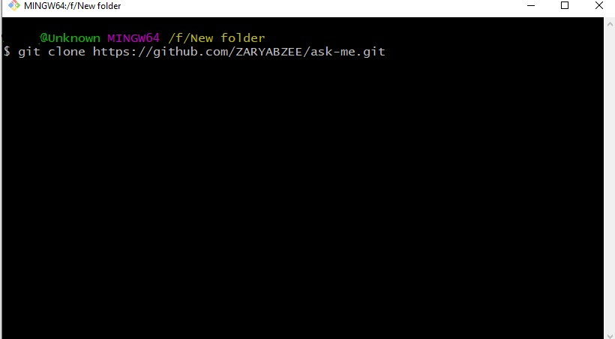

The code will be cloned directly into your folder from Github repo.

**VS Code:**

Then we have to open the project inside VS Code and do the following steps:

1. In the root directory we have to create .env file with the following values:
   1. NODE_ENV = development
   2. PORT = 5005
   3. MONGO_URI = YOU_MONGO_URI_STRING
   4. JWT_SECRET = abc123
2. Staying in the root directory we have to open the terminal window from VS Code and run the following command: **“npm install”** and it will install all the packages related to backend
3. From the terminal window we need to move to the frontend folder by typing the command: **”cd frontend”** and then again run the command **“npm install”**
4. After these procedures, we have to again come back to the root folder and run the following command: **“npm run dev”.** The Project will get open in the browser with the following domain: **“localhost:3005”**

**Summary:**

In this User Manual, we covered which tools and technologies are required for the project setup and how we can run the project. In the next documents, we will see the Alpha Testing and Beta Testing.